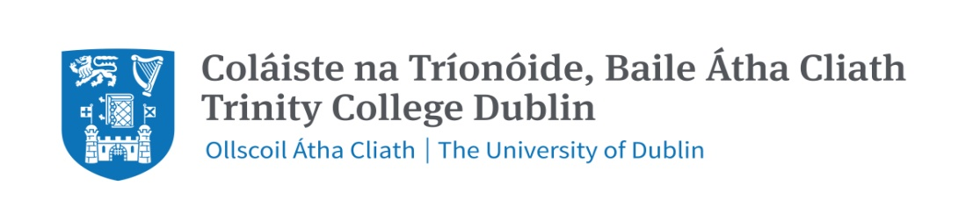

**FACULTY OF ARTS, HUMANITIES & SOCIAL SCIENCES**

**Trinity Business School**

**MSc Business Analytics**

**2020/21**  **Semester 1 2022**

**Group Assignment**

**BU7143 – Business Analytics**

**Instructions to Candidates**:

Answer each question separately, on a new page.

Due to the open book nature of this assignment, there is an expectation that students will (i) cite in more depth and breadth, (ii) have more accuracy in the information and more precision in defining prior assumptions underlying your answers, (iii) have more depth in the analysis, and (iv) be aware that plagiarism will be especially important to avoid: no verbatim texts.

There are four main criteria for evaluation of this examination:

1. **Understanding:** the answers should demonstrate an understanding of conducting operations analytics issues;
2. **Substantiation:** the answers should be underpinned primarily by module material;
3. **Insight**: the answers must demonstrate critical evaluation and insight into the analysis of operations management in the case study
4. **Clarity:** the answers should be well structured and clearly presented.

|  |  |
| --- | --- |
| **Mark out of 100%** | **Criteria** |
| 70 - 100 | A mark of 70-100 would suggest an excellent piece of work which includes a good description, detailed analysis and insightful evaluation. There will be appropriate and creative use made primarily of module material relevant to the issues. It will be easy to read, be well structured, and provide a cohesive and persuasive argument leading to action-oriented recommendations. Recommendations will be of a specific nature and include well-grounded consideration of cost, time, responsibility, impact and outcome, as appropriate. |
| 60 – 69 | A mark of 60-69 would suggest a detailed piece of work which includes a good description, detailed analysis and evaluation. There will be appropriate use made of module material. Recommendations for action will be of a specific nature and include some consideration of cost, time, responsibility, impact and outcome, as appropriate. |
| 50 – 59 | A mark of 50-59 would suggest a competent piece of work which includes a good description, analysis and evaluation. There will be appropriate use made of some module material. Recommendations for action will be of a general nature. |
| 0 – 49 | A mark below 50 would suggest a failing piece of work, predominantly descriptive. It will include some analysis, limited evaluation but without reference to appropriate module material. Recommendations for action, if present, will be of a general nature. |